10. GIT HUB ACTIONS

- INTRODUCTION
- Jenkins, Azure DevOps, and GitHub Actions are tools used to build CI/CD pipelines.

- CI vs CD
- CI (Continuous Integration)
- Used for: Build code, Run tests , Package application
- Happens frequently when code is pushed.

- CD (Continuous Deployment / Delivery)
- Continuous Deployment (CD) → Automatic deployment to server.
- Continuous Delivery → Manual approval before deployment.

  - Simple:
- Auto deploy = CD
- Manual deploy = Delivery

- Sir Explained Difference
- JENKINS | - AZURE DEVOPS | - GITHUB ACTIONS
- Requires:  - VM (Virtual Machine),  - Installation of Jenkins  - Setup of agents (slaves) | - Cloud-based DevOps platform  - Provides: Repos, Pipelines, Boards  - Can run pipelines: On cloud agents, On self-hosted agents | - Built into GitHub  - No separate installation needed
- Key Points:  - You must install and manage everything  - Uses : Groovy scripts  - Types : Declarative pipeline, Scripted pipeline  - Cost: VM cost , Maintenance cost  - High flexibility but needs setup effort | - Key Points:  - No need to install full setup like Jenkins  - Supports YAML pipelines  - Can integrate with Azure services easily | - Key Points :  - CI/CD is inbuilt  - Uses YAML workflows  Has its own execution system (runners)

- Runners / Agents
- Machines that execute pipeline jobs
- Types:
- Shared Runner:
- Managed by GitHub
- Temporary VM created
- Destroyed after job completion
- No maintenance

- Self-hosted (Private Runner)
- You create and manage VM
- Full control over environment
- Preferred by companies for security & customization

- Cost Comparison
- Jenkins : VM cost, Maintenance cost , Setup effort
- Azure DevOps : Some free usage , Paid for advanced usage
- GitHub Actions : Free tier available, Paid only if usage exceeds limits, No VM needed for basic usage

- Language Used
- Jenkins → Groovy
- GitHub Actions → YAML
- Azure DevOps → YAML

- Simply :
- Jenkins → Full control but needs setup
- Azure DevOps → Balanced cloud solution
- GitHub Actions → Easy, inbuilt CI/CD with GitHub

- Agent can be shared or private

- Difference between Github Actions, Azure DevOps and Jenkins
Category | GitHub Actions | Azure DevOps | Jenkins
1. Definition | Built-in CI/CD in GitHub to automate workflows | Complete DevOps platform by Microsoft | Open-source automation server for CI/CD
2. Workflow (Flow) | Code → Trigger → Workflow → Job → Runner → Steps → Output → Deploy | Code → Trigger → Pipeline → Stage → Job → Agent → Task → Artifact → Release | Code → Trigger → Pipeline → Stage → Step → Node → Build → Deploy
3. Why Used | Automate build, test, deploy directly from repo | Manage full SDLC (plan, code, build, release) | Automate CI/CD with full customization
4. Where Used | GitHub projects, startups, open-source | Enterprises, Microsoft ecosystem | On-prem, legacy systems, custom setups
5. Setup | No setup required | Minimal setup | Full manual setup required
6. Maintenance | None | Low | High
7. Pipeline Language | YAML | YAML | Groovy
8. Execution Machine Name | Runner | Agent | Node / Executor
9. Hosting Type | GitHub cloud only | Cloud + On-prem | Self-hosted
10. Cost | Free tier + paid usage | Paid (some free tier) | Free (infra cost required)
11. Integration | Best with GitHub ecosystem | Best with Azure services | Works with all tools via plugins
12. Scalability | High (auto scaling runners) | High (enterprise level) | Depends on infrastructure
13. UI/UX | Simple and clean | Advanced and feature-rich | Basic UI
14. Security | Good (GitHub-managed) | Very strong (enterprise-grade) | Depends on configuration
15. Speed | Fast (auto runners) | Fast | Depends on setup
16. Flexibility | Medium | High | Very high
17. Control | Limited | Medium | Full control
18. CI Support | Yes | Yes | Yes
19. CD Support | Yes | Yes | Yes
20. Deployment Support | GitHub Pages, cloud, servers | Azure, cloud, on-prem | Anywhere
21. Runners/Agents Types | GitHub-hosted, Self-hosted | Microsoft-hosted, Self-hosted | Self-managed nodes
22. Parallel Execution | Yes | Yes | Yes
23. Reusability | Reusable workflows | Templates | Shared libraries
24. Secrets Management | GitHub Secrets | Azure Key Vault | Plugins/manual
25. Artifact Storage | Available | Available | Available
26. Caching | Supported | Supported | Supported
27. Monitoring | Actions tab | DevOps dashboard | Plugins
28. Plugins/Extensions | Marketplace actions | Extensions marketplace | Huge plugin ecosystem
29. Learning Curve | Easy | Medium | Medium to High
30. Best For | Quick CI/CD, GitHub users | Enterprise DevOps lifecycle | Custom pipelines, full control
31. Advantages | Easy, inbuilt, no infra | Full platform, scalable | Flexible, powerful
32. Disadvantages | Limited infra control | Complex, paid features | High maintenance
33. Trigger Types | push, PR, schedule, manual | push, PR, schedule, manual | SCM, webhook, manual
34. Environment Support | Yes (env + approvals) | Yes (stages + approvals) | Yes (manual config)
35. Real-time Usage | Modern apps, open-source | Enterprises, large teams | Legacy + enterprise custom setups
36. Output | Logs, artifacts | Artifacts, releases | Build outputs
37. Deployment Type | Auto + manual | Auto + manual | Auto + manual
38. Summary | Simple & fast CI/CD | Complete DevOps ecosystem | Fully customizable CI/CD

- GITHUB ACTIONS WORK FLOW
- Pipeline Structure (Common for all)
- Flow : Code → Trigger → Workflow → Job → Runner → Steps → Output → Deploy

- Explanation:
- Repository → Stores code
- Workflow → Pipeline definition (YAML)
- Trigger → Event (push, manual, etc.)
- Job → Set of tasks
- Agent/Runner → Machine executing job
- Steps → Individual actions
- Tasks → Commands/scripts

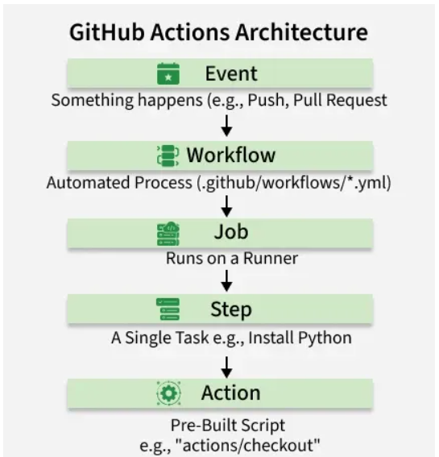

- GITHUB ACTIONS ARCHITECTURE

- Repository : Stores your code + workflow files
- Workflows are inside : .github/workflows/
- Entry point of automation

- Workflow : YAML file that defines the pipeline
- Contains: on (trigger), jobs
- Controls the entire automation process

- Event (Trigger) : Decides when workflow runs
- Defined using on
- Examples : push, pull_request, workflow_dispatch
- Starts the workflow execution

- Jobs : Group of steps
- Each job runs on a runner (VM)
- Example : Build job, Test job, Deploy job

- Runner (Agent) : Machine that executes jobs
- Types:
  - GitHub-hosted runner : Auto-created VM,
- Example: ubuntu-latest
  - Self-hosted runner : Your own VM
- Executes your code

- Steps : Small tasks inside a job
- Examples : Install dependencies, Run script, Execute commands

- Actions : Pre-built reusable tasks
- Saves time (no need to write everything)
- Examples : Checkout code, Setup Node.js

- Marketplace : Collection of ready-made actions
- Provided by GitHub/community
- Used to : Reuse code, Speed up pipeline creation

- Environment : Used for deployment control
- Features : Secrets, Approval rules
- Example : Production deployment

- Secrets : Store sensitive data securely
- Used in workflows safely
- Examples : Passwords, API keys

- Variables : Store reusable values
- Example : App name, Version

- Artifacts : Files generated during workflow
- Examples : Build files, Logs
- Can be downloaded later

- Cache : Stores dependencies
- Speeds up builds
- Example : npm packages

- GITHUB ACTIONS INTERNAL ARCHITECTURE

- Event System (Trigger Engine)
- Detects events like: push, pull_request, workflow_dispatch
- Starts workflow automatically

- Workflow Processor
- Reads YAML file from : .github/workflows/
- Validates syntax
- Converts workflow into execution plan
- Decides : Jobs, Order of execution

- Queue Manager
- Adds jobs into a queue
- Waits for available runners
- Handles : Load balancing, Job scheduling

- Runner Manager : Assigns jobs to runners
- Types : GitHub-hosted runners (auto VM)
  - Self-hosted runners (your VM)
- Chooses correct machine based on : runs-on

- Runner (Execution Machine) : Actual VM where job runs
- Responsibilities : Download code, Execute steps, Run scripts

- Actions Runtime
- Executes : Shell commands, Pre-built actions
- Supports : Docker actions, JavaScript actions
- Runs each step in order

- Container / VM Isolation
- Each job runs in: Fresh VM OR container
- Ensures : Security, Clean environment

- Logging System
- Captures : Output logs, Errors
- Helps debugging

- Artifact Storage
- Stores : Build outputs, Files
- Used to : Download results, Share between jobs

- Cache System
- Saves dependencies
- Speeds up future runs
- Example : npm packages, pip libraries

- Secrets Manager
- Stores sensitive data
- Injected securely into jobs
- Examples : Tokens, Passwords

- API & Webhooks Layer
- Communicates with : GitHub repo, External systems
- Used for : Integration, Automation triggers

- Permissions & Security Layer
- Controls access
- Ensures : Secure execution, Role-based permissions

- Billing & Usage Tracker
- Tracks : Minutes used, Resources consumed
- Used for cost calculation

- Internal Flow (Simple)
- Event occurs → Workflow read → Jobs created → Jobs queued → Runner assigned → Steps executed → Logs + Artifacts stored

- GitHub Actions internally works as:
Event → Processor → Queue → Runner → Execution → Storage

- CREATE A GITHUB ACTION FILE
  - From Starting create file to execute and check
- Create Repository
- Go to GitHub
- Click New Repository
- Add your project files (HTML, CSS, etc.) ( optional )

- Open Actions Tab
- Inside your repo
- Click on Actions tab

- Configure Workflow
- Click “Set up a workflow yourself”
OR
- Click “Configure” from suggested templates

- Write Workflow File
- GitHub automatically creates a YAML file
- Location : .github/workflows/<file-name>.yml

- Add Workflow Code
- Write your pipeline (build/test/deploy steps)

- Commit the File
- Click Commit changes
- File gets saved in repo

- Workflow Execution
- Based on trigger : Manual (workflow_dispatch), Push, Pull request
- Workflow starts automatically

- View Execution
- Go to Actions tab
- Click workflow run
- Check logs, status, output

- Simple Flow : Repo → Actions → Create Workflow → Save in .github/workflows → Run → View Results

- SAMPLE YAML CODE
- Sample 1 :
name: demo
on: workflow_dispatch
jobs:
test:
runs-on: ubuntu-latest
steps:
- run: echo "Hello"

- Sample 2 :
name: hello world
on:
workflow_dispatch:
jobs:
hello:
runs-on: ubuntu-latest
steps:
- name: print hello world
run: echo "hello world"

- Code explanation:
- name: hello world
name → Name of the workflow (just a label shown in Actions tab).

- on:
workflow_dispatch:

on → Defines when the workflow should run.
workflow_dispatch → Allows you to run this workflow manually from GitHub UI.

- jobs:
jobs → A collection of tasks (workflows contain one or more jobs).

- hello:
hello → Job ID (you can give any name; used to identify this job).

- runs-on: ubuntu-latest
runs-on → Specifies the runner (machine/environment to execute the job).
ubuntu-latest → Latest Ubuntu Linux virtual machine provided by GitHub.

- steps:
steps → Sequence of actions/tasks executed inside the job.

- - name: print hello world
- → Indicates a list item (each step is an item).
name → Friendly name of the step (displayed in logs).

- run: echo "hello world"
run → Executes a shell command.
echo "hello world" → Prints "hello world" in the console output.

- Simply :
- Workflow name is hello world
- Trigger = manual run
- One job = hello
- Runs on Ubuntu machine
- Executes one step → prints hello world

- on in GitHub Actions (Triggers)
- on defines when the workflow should run
- It is called a trigger

- Types of on (Triggers)
- Manual Trigger : workflow_dispatch
- Used to run workflow manually from UI

- Push Trigger : push
- Runs when code is pushed to repo
- Used in: CI pipelines

- Pull Request Trigger : pull_request
- Runs when PR is created/updated
- Used for code review validation

- Schedule Trigger : schedule
- Runs at fixed time (cron job)
- Used for : Night builds, Cleanup jobs

- Repository Events
- create → branch/tag created
- delete → branch/tag deleted
- Used for automation based on repo changes
- fork → repo forked
  - Fork = creating a personal copy of someone else’s repository
  - When a user clicks “Fork” button on a repo
  - To make changes without affecting original repo
  - To contribute (via pull requests)
  - To experiment safely
- Original repo → owned by someone
- You fork → copy comes to your account
- You edit → no impact on original

- watch → repo starred
  - Watch/Star = marking a repository as favorite
  - When a user clicks “Star” button
- To bookmark repository
- To follow useful projects
- To show appreciation/popularity

Feature | Fork | Watch (Star)
Action | Copy repo | Mark repo
Code copy | Yes | No
Used for | Development | Tracking
Changes allowed | Yes | No

- Release Events : release
- Runs when release is published

- Issue Events : issues
- When issue is opened/closed

- Pull Request Review : pull_request_review
- When review is added

- Workflow Trigger : workflow_call
- Call one workflow from another

- Workflow Run : workflow_run
- Run after another workflow completes

- Deployment Events : deployment or deployment_status
- Used in CD pipelines

- Check Events : check_run or check_suite
- Used for CI status checks

- Simply :
- Used to decide when pipeline runs
- Used in CI/CD automation

- Job in github actions
- A job = group of steps
- Runs on a runner (VM)
- Types of Jobs
  - Note : GitHub Actions does NOT have fixed “named job types” like tools, but jobs are categorized based on usage:

- Single Job : Only one job in workflow
- Used for simple tasks

- Multiple Jobs : Many jobs in one workflow
Used for : Build + Test + Deploy separately

- Sequential Jobs : Jobs run one after another
- Uses : needs,
- Example : Build → Test → Deploy

- Parallel Jobs : Jobs run at same time
- Used to : Save time, Run tests on multiple environments

- Matrix Jobs : Same job runs with multiple configs
- Example : Different OS (Windows, Linux), Different versions (Node 14, 16)

- Reusable Jobs : Defined in another workflow
- Called using : workflow_call,
- Used for : Common pipelines

- Self-hosted Runner Jobs : Runs on your own VM
- Used for : Security, Custom environment

- GitHub-hosted Runner Jobs : Runs on GitHub VM
- Example : ubuntu-latest,
- Used for : Quick setup, No maintenance

- Conditional Jobs : Run only if condition is true
- Uses : if
- Example : Deploy only on main branch

- Deployment Jobs : Used for deployment
- Uses : environment
Example : Deploy to production

- Job Structure
jobs:
job_name:
runs-on: ubuntu-latest
steps:
- run: command

- Summary of Jobs
Job = execution unit
Runs on runner
Can be : Parallel, Sequential, Conditional, Matrix-based

- On : Controls WHEN pipeline runs
- Jobs : Controls WHAT pipeline does

- A job = group of steps
- Runs on a runner (VM)

for writing multiple lines in run we use pipe symbol |
run: |
echo "hello world"
echo " Hello SAI"

- For running multiple jobs
jobs:
build:
runs-on: ubuntu-latest
steps:
- name: print hello world
run: echo "this is build file "
test:
runs-on: ubuntu-latest
steps:
- name: print hello world
run: echo "this is build file "
deploy:
runs-on: ubuntu-latest
steps:
- name: print hello world
run: echo "this is build file "

backend there are 3 machines
each machine execute jobs parallel
and machine gets destroyed
each workflow will have jobs and each jobs will have runners

- For depends on another job and sequential order
  - We use needs keyword
jobs:
build:
runs-on: ubuntu-latest
steps:
- name: print hello world
run: echo "this is build file "
test:
runs-on: ubuntu-latest
needs: build
steps:
- name: print hello world
run: echo "this is build file "
deploy:
runs-on: ubuntu-latest
needs: test
steps:
- name: print hello world
run: echo "this is build file "

Result :
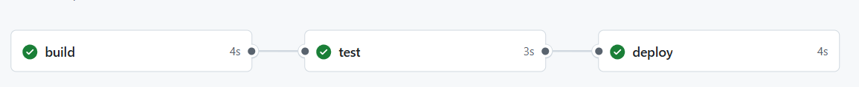

- For push command :
name: hello world
on: push
jobs:
build:
runs-on: ubuntu-latest
steps:
- name: print hello world
run: echo "this is build file1 "
test:
runs-on: ubuntu-latest
needs: build
steps:
- name: print hello world
run: echo "this is build file 2"
deploy:
runs-on: ubuntu-latest
needs: test
steps:
- name: print hello world
run: echo "this is build file 3"

if on is push
when you edit code manually in pc and push to github actions would automatically triggers
when any changes occurs in pipeline automatic it would trigger

before push
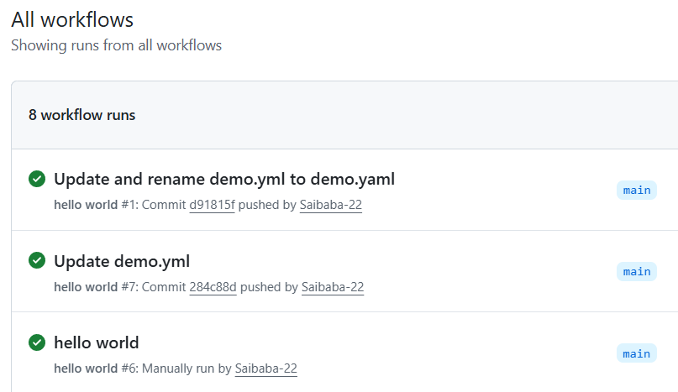

After push
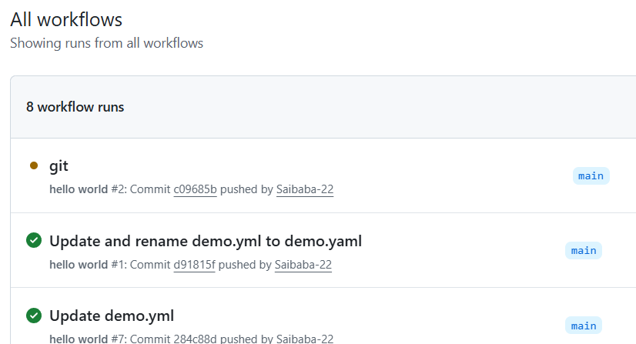

- For pull request
if we have multiple branches and merge one branch to another branch then we raise pull requests
using git clone git repo
create a new branch using git
git branch feature
git checkout feature
now we are in feature branch
from main page click on compare and pull request
click on create a pull request

push code to new branch and make a pull request

name: hello world
on:
push:
pull_request:
branches:
- main
jobs:

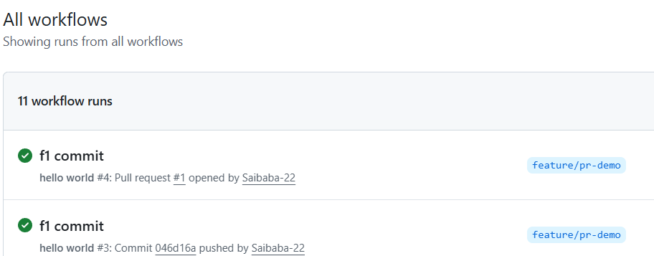

- For variable

name: demovariable
on: workflow_dispatch
jobs:
variable:
runs-on: ubuntu-latest
steps:
- name: print variable
run: echo hello, ${{vars.MY_NAME}}

Github -> settings -> secrets and variables -> actions -> variable
Click on new repository variable
Name : mention variable name which is declared in yaml file
Ex : $MY_NAME type as MY_NAME
Value : type anything

- INPUT PARAMETERS

In run time what are parameters you need, you can pass the values
One work flow for different environments
Push and branch name for pushing to required branch

For providing inputs
Triggering should be manually only
For inputs required line is mandatory

Code :

name: inputdemo
on:
workflow_dispatch:
inputs:
environment:
description: this is demo input
required: true
default: dev
jobs:
inputdemo:
runs-on: ubuntu-latest
steps:
- name: run input demo
run: echo " deploy the application to ${{inputs.environment}}"

after saving code
directly go to github actions and run the code

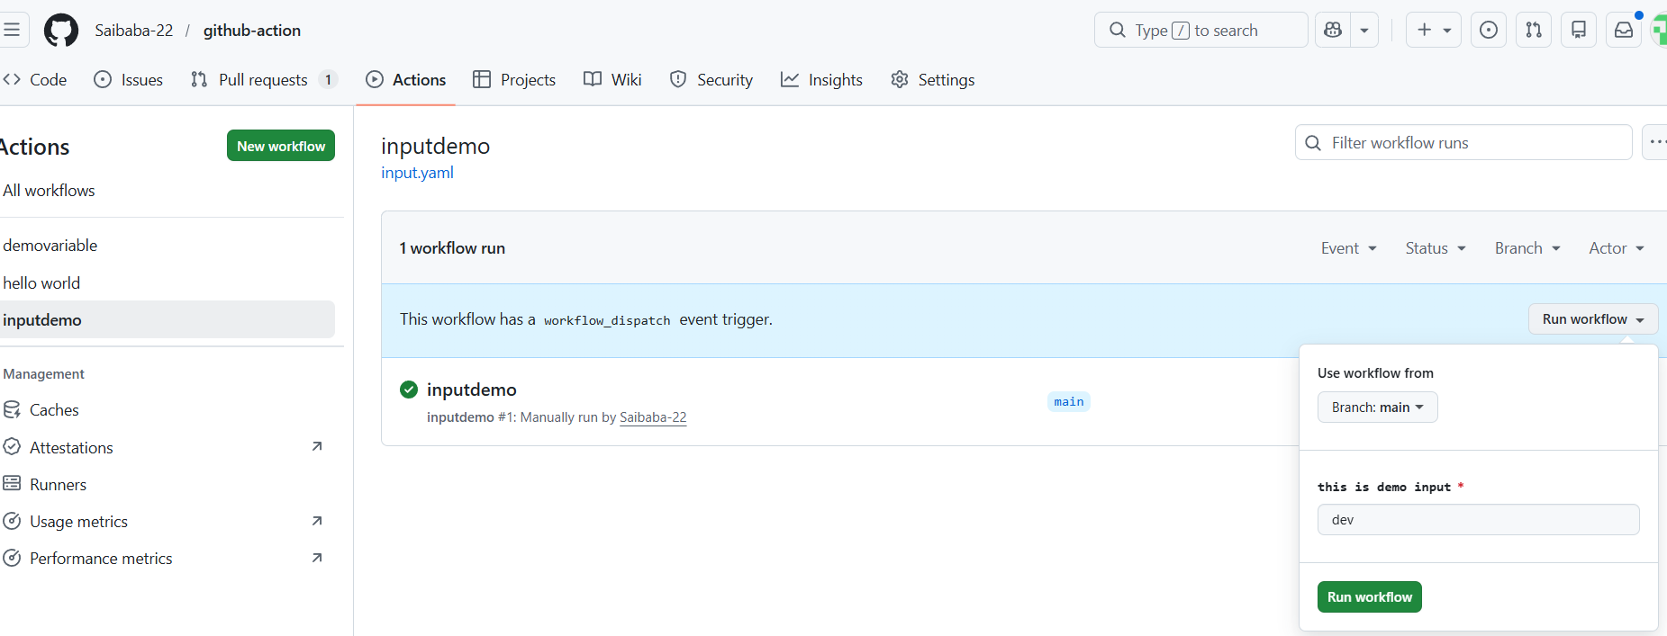

Under work flows : select file name,
Click on run workflow
Provide any value or leave it and click on run

- For multiple input values :

inputs:
environment:
description: this is demo input
required: true
default: dev
tags:
description: this is tag demo
required: true
default: tag

- Changes in run line

run: echo " deploy the ${{inputs.tags}} application to ${{inputs.environment}}"

Under work flows : select file name,
Click on run workflow
Provide any value or leave it and click on run

result :
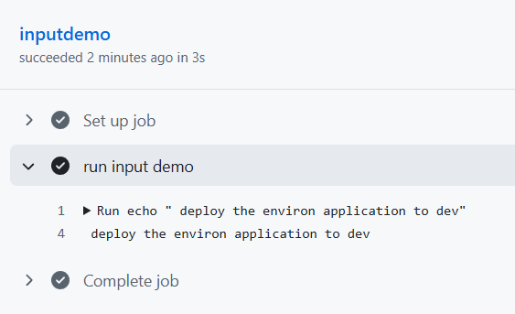

- For options
Code is same
Just add this type and options

inputs:
environment:
description: this is demo input
required: true
default: dev
type: choice
options:
- dev
- prod
- uat
tags:
description: this is tag demo
required: true
default: tag

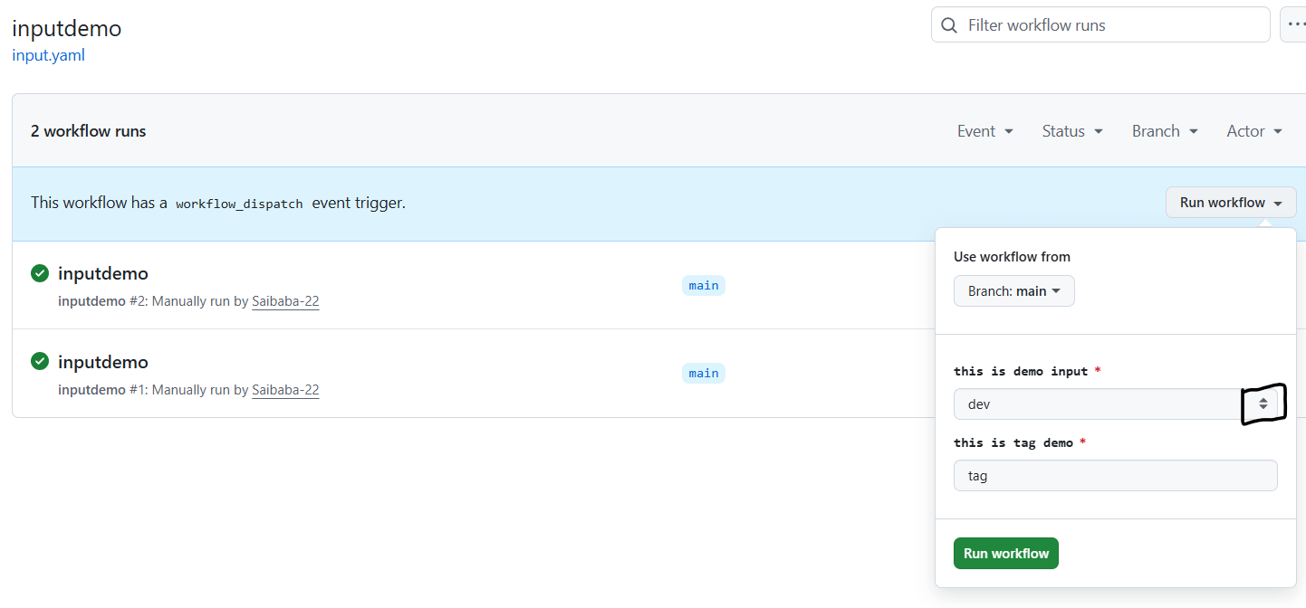

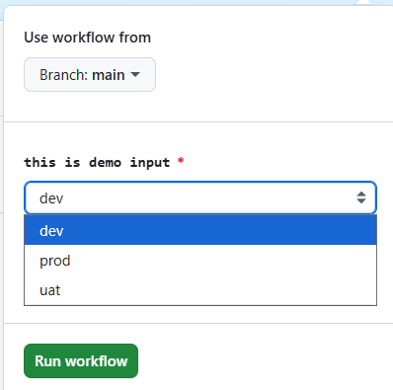

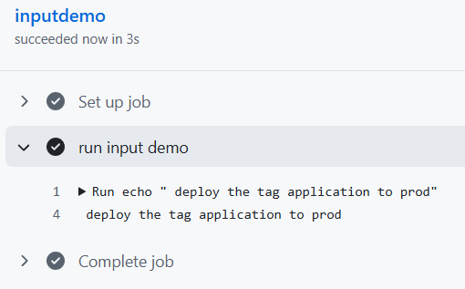

- Actions

If we have any code just we can call it and execute without username and password

- Github actions checkout official page : https://github.com/actions/checkout

My code for demo
File name : index.html
Code inside it : <h2> this is file </h2>

Github action code in yaml :

name: actiondemo
on: workflow_dispatch
jobs:
demo:
runs-on: ubuntu-latest
steps:
- name: actiondemo
uses: actions/checkout@v4
- name: print index file
run: cat indec.html

- Now executing a website without cloud

If you have any code or project upload it to github

- Now execute a website with cloud

Using AWS:
After completing AWS S3 bucket topic once practice it
In github actions aws cli commands are default
So we can run commands directly

Using Azure :
Get a storage account and try

- USING TERRAFORM

1 Connection from aws to github : open idconnect
Complete part using cloud

